ar, konvensjne
Defensive and Competitive Bidding
Overcalls (Style; Responses; Reopening)
1-level: Light
2-level: Sound
Responses: 1-level F1, 2-level constructive, 3-level GF. Jumps are minisplinter, double jumps Splinter, cue-bid is a good raise in overcaller’s suit.
1 NT overcall (2ND/4TH; Responses; Reopening)
15-18 HCP.
Same responses as after opening 1NT.
Jump Overcalls (Style; Responses; Unusual NT)
1-Suit: Light jump overcalls, but not bad red vs. white
2-Suit: 2NT = 2 lowest suits (5+-5+) weak/strong
Direct and Jump Cue Bids (Style; Responses)
Over 1♣: 2♣ = ♣, 2♦= both M (5+-5+), 2 NT= ♥/♦ (5+-5+)
Over 1♦: 2♦= Both Majors (5+-5+), 2 NT = ♥/♣ (5+-5+)
Over M: Other Major + ♣ (5+-5+), 2 NT = ♦/♣ (5+-5+)
Jump cue-bid: Asks for stopper
VS. NT (vs. Strong/Weak; Reopen: PH)
2♣ = Both Majors
2♦ = ♥ OR ♠
2♥ = ♥ and a minor (usually longer, 4(5) ♥ and 5+minor)
2♠ = ♠ and a minor (usually longer, 4(5) ♠ and 5+minor)
2NT =Both minors OR any Strong 2-suiter
4th seat and after initial pass: DONT
VS. Preempts (Doubles; Cue bids; Jumps; NT bids)
Take out DBL (Lebensohl)
4m: leaping michaels (GF with 5+ and 5+ in other Major)
Jump overcall in Major: Good hand.
Cue-bid: Ask for stopper
Over 3M: 4m natural
VS. Artificial Strong Openings
VS. 2 ♦ Multi
DBL = Takeout vs ♠ or strong
2NT = 15-18 HCP, (semi)balanced

Leads and Signals
Opening Leads Style
 | Lead |  |  | In Partner’s Suit
Suit | 3rd/5th |  |  | 3rd/5th
NT | 3rd/5th |  |  | 3rd/5th
Subseq | Attitude
Leads
Lead |  | Vs. Suit |  | Vs. NT
Ace |  | AK, Ax, A |  | Axx(x)
King |  | AK, KQ(x) |  | KQ(x), AKJ10(x), KQ109(x) AKQ(x)
Queen |  | QJ(x), |  | QJ(x), AQJx(x),
Jack |  | J10(x), KJ10(x) |  | J10(x), HJ10(x)
10 |  | 109(x), H109(x) |  | 109(x), H109(x)
9 |  | 9x |  | 9x, 98(x)(x)
Hi-X |  | Even number |  | Normally even number
Signals in order of priority
 |  | Partners lead | Declarer |  | Discarding
Suit: |  | Encrg/Discrg | Count |  | Encrg/Discrg
2nd |  | Count | Count |  | Count
3rd |  | Count | Count |  | Count
NT: |  | Encrg/Discrg | Count |  | Encrg/Discrg
2nd |  | Count | Count |  | Count
3rd |  | Count | Count |  | Count
Signals (including Trump’s):
Hi-Low = Discrg/Even number, Low-Hi = Encrg/Odd number
Smith (NT): Hi-Low likes the lead from both.
Lavinthal: Obvious positions, and possibly when declearer leads.
Doubles
Takeout Doubles (Style; Responses; Reopening)
Light style, also reopenings
Special, Art and Comp Dbl/Rdbl’s
Neg, Responsive, Support DBL to 2♥, Competitive DBL
1♣ - (1♦) – DBL shows both Majors
1m - (1♥) - 1♠ shows 5+♠,
1m - (1♥) - DBL shows exactly 4 ♠,
1m- (1♠) - DBL strongly suggests at least 4♥

  WBF | System Card |  | 
 | 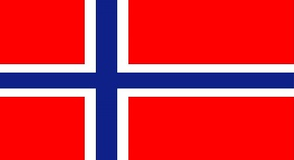
Category: |  | Green
NCBO:  Norway Seniors | 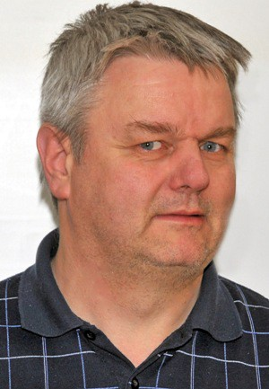 |  | 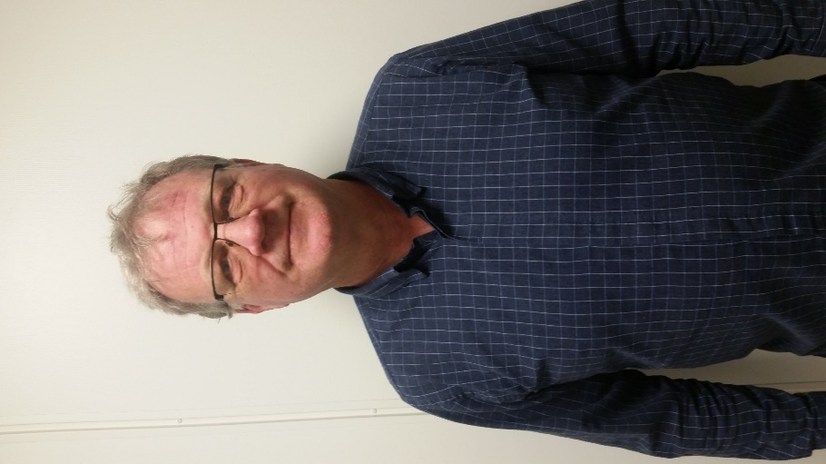
Event:
2021
Players: | Lars Erik  Eide |  | Odd A. Frydenberg
System Summary
General Approach and Style
Natural, 5c Μ . 3rd hand openings may be light
Light preempts green vs. red

1NT Openings: (14)15-17 HCP (5M/6m/single/5422)
2-over-1 Responses: GF except rebid in the minors
Special bids that may require defence
Special forcing pass sequences
When GF established
After 1m-(p)-2m-(2/3x)
After 1M-(p)-2NT-(3x)
Important notes that don’t fit
xy-NT/xyz: 2♣=sign off in ♦ OR INV, 2♦=GF
Psychics
Rare, but might occure.

 |  | Opening |  |  | Art |  |  | Min. # |  |  | Neg. D. thru |  |  | Description |  |  | Responses |  |  | Subsequent Auction | Passed Hand Bidding
 |  | 1♣ |  |  |  |  |  | 3 |  |  | 5♦ |  |  | 10+ HCP, 3+♣ |  |  | 1♦/♥/♠ = 6+ HCP and 4+ cards in the suit  Walsh: 1♥/♠ can have longer ♦ if weak.  1 NT = 6-10 HCP (no majors) 2♣ = GF w/ 4+♣.  3♣ = Preemptive (about 0-5 HCP) 2♦ = Inv w/ 5+♣. 2♥/♠ = 8-11 HCP, 6(+)cards. 2 NT = 11-12 HCP.  3♥/♠ = Shortness w/5+♣. 3 NT = 13-15 HCP. |  |  | 1♣-1♦-1♥/♠ = Unbalanced  1♣-1♦-NT= 11-14 balanced, can have 4c ♥/♠ | 2♣ = 6-9 HCP w/ ♣.  2♦ = 10-11 HCP w/ ♣
 |  | 1♦ |  |  |  |  |  | 3 |  |  | 5♦ |  |  | 10+ HCP, 3+♦  (3♦ only if 4-4-3-2) |  |  | 1♥/♠ = 6+ HCP and 4+ cards in the suit  1 NT = 6-10 HCP (no majors) 2♣ = GF if not rebid. 2♦ = GF w/ 4+♦. 2♥/♠ = 8-11 HCP, 6(+)cards  2 NT = 11-12 HCP. 3♣ = Inv w/ 5+♦  3♦ = Preemptive (about 0-5 HCP)  3♥/♠ = Shortness w/ 5+♦. GF. 3 NT = 13-15 HCP |  |  |  | 2♦ = 6-9 HCP w/ ♦.  3♣ = 10-11 HCP w/ ♦
 |  | 1♥ |  |  |  |  |  | 5 |  |  | 5♦ |  |  | 10-22 H CP, 5+♥ |  |  | 1NT=6-12 HCP NF, 2♣= a)GF if not rebid. b) inv (9+-12-HCP) w/ 3♥ 2♦= GF if not rebid. 2♥= 5-9 w/3+♥. 2♠=shortage in m 2NT=4+♥ GF. 3♣ = 6-9 or 10-11 w/4+♥, no shortness. 3♦= shortage in ♠. 3♥= pre-empt. 3♠=to play. 3NT=void in ♠. 4♣/4♦=void. |  |  | 1♥-2NT, 3♣/♦/ ♠ = Natural, extra values  1♥-2NT, 3♥=Minimum  1♥-2NT, 4♣/♦/ ♠ = void  1♥-2NT, 4♥ = void in ♠, minimum | 1♥-2♣ = good raise w/ 3 ♥  1♥-2♦ = good raise w/ 4+ ♥  1♥ - 2♠/3♣/3♦ =  shortness, 4+♥
 |  | 1♠ |  |  |  |  |  | 5 |  |  | 5♦ |  |  | 10-22 HCP, 5+♠ |  |  | Similiar as for 1♥. 2♥ = GF. |  |  | Similiar as for 1♥ | Similiar as for 1♥
 |  | 1 NT |  |  |  |  |  |  |  |  | 5♦ |  |  | (14)15-17 HCP (Good 14 to 17)  May have 5c M, 6c m, (5-4-2-2) and singleton |  |  | 2♣=Stayman, 2♦/2♥=Transfer to 2♥/2♠.  2♠ = Transfer to ♣. 2NT= Both minors, weak/strong.  3♣ = Transfer to ♦. 3♦= Invitational to 3 NT, normally solid suit.3♥/♠= shortness GF. 4♣/♦ = Texas. |  |  | 1NT-2♣, 2♦-2♥=pick a M; bid 2♠ w/ equal length. 1NT-2♣, 2♥-2♠= Inv w/ 4♠  1NT-2♣, 2♦-2♠= both M (5+-5+),GF.  1NT-2♣, 2♦♥♠-3♣=Asking bid.
 |  | 2♣ |  |  | ∨ |  |  |  |  |  |  |  |  | Strong, HCP (22+) OR tricks (8,5+) |  |  | 2♦=Weak OR waiting,  2M=GF, at least 5 card suit  2NT= GF w/5-5 minors,  3m=GF, at least HHxxxx
 |  | 2♦ |  |  |  |  |  | 6 |  |  |  |  |  | 6(+)♦, 5-10 (11) HCP |  |  | 2♥/♠= constructive, 2NT=Ask for values in other suits 3♣= NAT GF. 3/4♦=Preempt. 3♥/♠= NAT GF. 4♥/♠=To play |  |  | 2♦-2NT,  3♣/♥/♠= values in that suit NT  3♦= Minimum  3 NT = solid suit
 |  | 2♥ |  |  |  |  |  | 6 |  |  |  |  |  | 6(+) ♥, 5-10 (11) HCP |  |  | 2♠= NAT F1, 2NT=Ask for shortage 3♣/♦= NAT GF. 3♥=Preempt. 3♠= NAT GF. 4♣/4♦=Splinter |  |  | 2♥-2NT-4♣,4♦=Void, 4♥ = void in ♠
 |  | 2♠ |  |  |  |  |  | 6 |  |  |  |  |  | 6(+)♠, 5-10 (11) HCP |  |  | Similiar as for 2♥. 4♥ = To play. |  |  | Similiar as for 2♥
 |  | 2 NT |  |  |  |  |  |  |  |  | 5♦ |  |  | 20-21 HCP |  |  | 3♣ = Puppet, 3♦/3♥ = TRF and GF, 3♠ = 44+m |  |  | 2NT-3♣, 3♦=At least one 4c M, 3♥/3♠=5c, 3NT=Denies 4/5 c M
 |  | 3x |  |  |  |  |  | (6)7 |  |  |  |  |  | PRE, 2-10 HCP  ACC to VUL |  |  | New suit = Forcing  3NT= To play. 4♥/♠=To play
3NT |  |  | ∨ |  |  |  |  |  |  |  |  | Solid minor, gambling (no side A or K in 1st and 2nd seat) |  |  | 4♣=p/c, 4♦= asking for shortness |  |  | High Level Bidding
4♣ |  |  |  |  |  | 7 |  |  |  |  |  | PRE, ACC to VUL |  |  | 4♦=cuebid, 4♥♠=To play, 4NT=BW |  |  | RKCB (1430)
 | 4♦ |  |  |  |  |  | 7 |  |  |  |  |  | PRE, ACC to VUL |  |  | 4♥♠=To play, 4NT=BW |  |  | Exclusion RKCB, DOPI/ROPI
 | 4♥,♠ |  |  |  |  |  | 7 |  |  |  |  |  | PRE, ACC to VUL |  |  | 4♠=To play  5m=Cuebid |  |  | 5NT is frequently pick a slam.
 | 4NT |  |  | ∨ |  |  |  |  |  |  |  |  | Asks for specific aces |  |  | 5♣=0 Ace, 5NT=2Aces, 5♦/5♥/5♠/6♣= that Ace |  |  | Splinter bids
 |  |  |  |  |  |  |  |  |  |  |  |  |  |  |  |  |  |  | Cue-bids (Italian style)

